**I-Flights Intranet User Manual**

**Intranet Software Manual**

Software Manual, June 2015

I-Flights Project Manager

Michael H. Youssef

**I-Valley**

▪Heliopolis Cairo, Egypt ▪ (0020) 128 4040 78

▪ sales@i-valley.com ▪ www.i-valley.com

**SOFTWARE DESCRIPTION**

I-Flights Intranet Version 1.0.0

**Description**

I-Flights Intranet is a used to track, manage and store documents. It’s capable of keeping a record of the various versions created and modified by system admins (history tracking).

**Benefits and Value**

Values and benefits provided by I-Flights Intranet are:

* Better version control.
* Increased document security and control.
* Enhanced Security.
* Secure Back-Ups.

**Platform Requirements**

I-Flights Intranet works on any internet browser.

**CONTENTS**

**1 FEATURES 5**

**2 ADMIN GUIDE 6**

Manage Circulars 8

Manage Bulletins 9

Manage Blog 10

Manage Categories 11

Manage Manuals 12

Manage Links 14

Manage Users 15

User Roles 16

Send Notifications 17

**3 USER GUIDE 18**

Home 19

Circulars 19

Bulletins 20

Blog 21

Manuals/Aircraft Manuals 22

Profile and changing Password 24

**4 NOTIFICATION MODULE 2****5**

***1***

**FEATURES INCLUDED IN I-FLIGHTS INTRANET**

The System is comprised of the following:

* Circulars and Bulletins publishing.
* Manuals version controller.
* Notification module.
* User management.
* Sending email notifications.

The System is designed to facilitate managing documents, and to secure the managing system offering high level of document management with easy accessibility

***2***

**ADMIN GUIDE**

I-Flights Intranet contains specific admin panels to manage documents and contents all over the system.

**Settings Menu**

In case of admin login, there will be an additional menu (settings) that contains all links for managing documents and data (see figure 2-1)

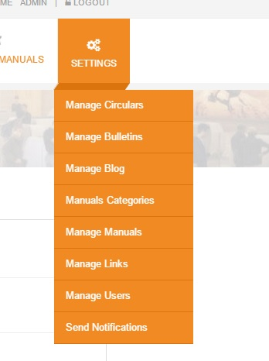

Figure (2-1)

* Manage Circulars: where admin can create new Circulars or edit/delete already existing Circulars.
* Manage Bulletins: where admin can create new Bulletins or edit/delete already existing Bulletins.
* Manage Blog: where admin can create new Blogs or edit/delete already existing Blogs.
* 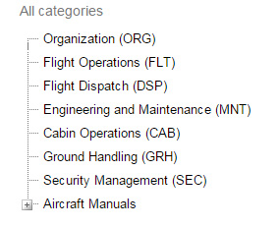Manuals Categories: where admin can manage Manual categories, either Creating new categories or sub-categories, or editing/deleting already existing categories (see figure 2-2).

Figure (2-2)

* Manage Manuals: where admin can:
  + Create, edit and delete manuals.
  + Create, edit and delete manual versions.
  + Create, edit and delete manual forms.
  + Create, edit and delete manual form versions.
* 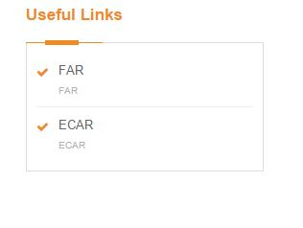Manage Links: where admin can create new useful link or edit/delete already existing links which are located in the Home page (see figure 2-3)

Figure (2-3)

* Manage Users: where admin can manage users including creating/editing/deleting users, the ability to change each user’s role to act in the system (See User Roles).
* Send Notifications: where admin can send E-Mail Notifications to any of the system users whether by name, email, username, or even by group.

**Manage Circulars**

**Creating New Circular**

1. Click on “Add New Circular” button which located at the top of the table (see figure 2-6).
2. Fill in the required fields.
3. Click on “Save” button located at the bottom of the page (see figure 2-6).

**Editing already existing Circular**

1. Click on “Edit” icon which located in the Actions column in the table (see figure 2-4).
2. Edit the required fields.
3. Click on “Save” button located at the bottom of the page (see figure 2-6).

**Deleting already existing Circular**

1. Click on “Delete” icon which located in the Actions column in the table (see figure 2-5).
2. 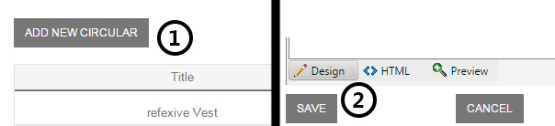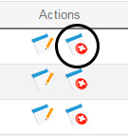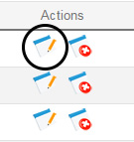Click on “OK” confirming deleting.

Figure (2-4) Figure (2-5) Figure (2-6)

**Manage Bulletins**

**Creating New Bulletin**

1. Click on “Add New Bulletin” button which located at the top of the table (see figure 2-9).
2. Fill in the required fields.
3. Click on “Save” button located at the bottom of the page (see figure 2-9).

**Editing already existing Bulletin**

1. Click on “Edit” icon which located in the Actions column in the table (see figure 2-7).
2. Edit the required fields.
3. Click on “Save” button located at the bottom of the page (see figure 2-9).

**Deleting already existing Bulletin**

1. Click on “Delete” icon which located in the Actions column in the table (see figure 2-8).
2. Click on “OK” confirming deleting.

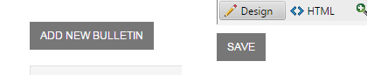

Figure (2-7) Figure (2-8) Figure (2-9)

**Manage FlyEgypt Blog**

**Creating New Blog**

1. Click on “Add New Blog” button which located at the top of the table (see figure 2-10).
2. Fill in the required fields.
3. Click on “Save” button located at the bottom of the page (see figure 2-10).

**Editing already existing Blog**

1. Click on “Edit” icon which located in the Actions column in the table (see figure 2-11).
2. Edit the required fields.
3. Click on “Save” button located at the bottom of the page (see figure 2-10).

**Deleting already existing Blog**

1. Click on “Delete” icon which located in the Actions column in the table (see figure 2-12).
2. Click on “OK” confirming deleting.



Figure (2-10) Figure (2-11) Figure (2-12)

**Manuals Categories**

**Creating New Root Category**

1. Click on “Add New Root Category” button which located at the top left of the page (See Figure 2-16).
2. Fill in the required fields.
3. Click on “Save” button (See Figure 2-19).

**Creating Sub-Category**

1. First choose the category from the left Tree in which you want to create a sub-category for (See Figure 2-15).
2. Click on “Add New Sub-Category” button which located at the top left of the page (See Figure 2-18).
3. Fill in the required fields.
4. Click on “Save” button (See Figure 2-19).

**Editing Already Existing Category**

1. A) Edit Root Category: Click on “Load Root Categories” (See Figure 2-17).  
   B) Edit Sub-Category: Click on the Parent Category to load its sub-categories.
2. Click on the “Edit” icon which located at the top left of the page (See Figure 2-11).
3. Fill in the required fields.
4. Click on “Save” button (See Figure 2-19).

**Deleting Already Existing Category**

1. A) Delete Root Category: Click on “Load Root Categories” (See Figure 2-17).  
   B) Delete Sub-Category: Click on the Parent Category to load its sub-categories.
2. Click on the “Delete” icon which located at the top left of the page (See Figure 2-12).
3. Fill in the required fields.
4. 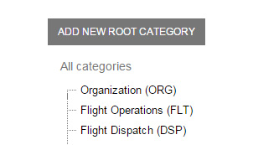Click on “Save” button (See Figure 2-19).

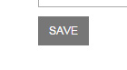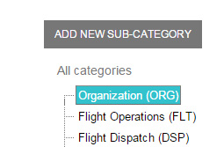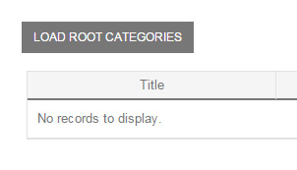Figure (2-13) Figure (2-14) Figure (2-15) Figure (2-16)

Figure (2-17) Figure (2-18) Figure (2-19)

**Manage Manuals**

**Creating New Manual**

1. Click on “Add New Manual” button which located at the top left of the page (see figure 2-21).
2. Fill in the required fields.
3. Click on “Save” button (see figure 2-20).

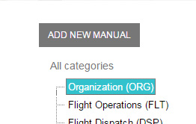After creating manual there will be options to add new version to this manual and also adding new forms to this manual, where each forms contains its own form versions.

Figure (2-20) Figure (2-21)

**Creating/Editing/Deleting Manual Version**

1. A) After creating new Manual: you’ll be in the page for this Manual where you can add new Manual Versions or edit/delete them.  
   B) Otherwise: go to Manage Manuals, select the desired category, and then click on the “Edit” icon for the desired Manual (See Figure 2-22).
2. A) Create: Click on “Add New Version” button (See Figure 2-24).  
   B) Edit: Click on the “Edit” icon for the desired Manual Version (See Figure 2-22).  
   C) Delete: Click on the “Delete” icon for the desired Manual Version and confirm deleting, skip 3 and 4 (See Figure 2-23).
3. Fill in the required fields.
4. Click on “Save” button (see figure 2-20).

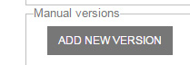

Figure (2-22) Figure (2-23) Figure (2-24)

**Creating/Editing/Deleting Manual Form**

1. Go to Manage Manuals, select the desired category, and then click on the “Edit” icon for the desired Manual (See Figure 2-22).
2. Click on “Edit Manual Forms” button (See Figure 2-25).
3. A) Create: Click on “Add New Form” button (See Figure 2-26).  
   B) Edit: Click on the “Edit” icon for the desired Manual Form (See Figure 2-22).  
   C) Delete: Click on the “Delete” icon for the desired Manual Form and confirm deleting, skip 4 and 5 (See Figure 2-23).
4. Fill in the required fields.
5. Click on “Save” button (See Figure 2-20).

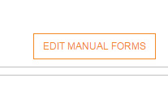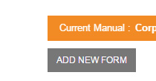

Figure (2-25) Figure (2-26)

**Creating/Editing/Deleting Form Version**

1. Go to Manage Manuals, select the desired category, and then click on the “Edit” icon for the desired Manual (See Figure 2-22).
2. Click on “Edit Manual Forms” button (See Figure 2-25).
3. Click on the “Edit” icon for the desired Form (See Figure 2-22).
4. A) Create: Click on “Add New Version” button (See Figure 2-25).  
   B) Edit: Click on the “Edit” icon for the desired Form Version (See Figure 2-22).  
   C) Delete: Click on the “Delete” icon for the desired From Version and confirm deleting, skip 5 and 6 (See Figure 2-23).
5. Fill in the required fields.
6. Click on “Save” button (See Figure 2-20).

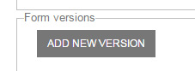

Figure (2-25)

**Deleting Already Existing Manual**

1. Go to Manage Manuals, Select the desired Category.
2. Click on the “Delete” icon for the desired Manual (See Figure 2-23).
3. Confirm deleting.

**Manage Links**

This section is to manage useful links section located in the Home page

**Creating New Link**

1. Click on “Add New Link” button which located at the top of the table (see figure 2-26).
2. Fill in the required fields.
3. Click on “Save” button located at the bottom of the page (see figure 2-26).

**Editing already existing Link**

1. Click on “Edit” icon which located in the Actions column in the table (see figure 2-27).
2. Edit the required fields.
3. Click on “Save” button located at the bottom of the page (see figure 2-26).

**Deleting already existing Link**

1. Click on “Delete” icon which located in the Actions column in the table (see figure 2-28).
2. Click on “OK” confirming deleting.

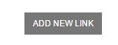

(Figure 26) (Figure 27) (Figure 28)

**Manage Users**

This section is to manage users’ authentication and roles, there is a search-bar to search for current existing users.

**Create new User**

1. Go to Manage Users page.
2. Click on “Add New User” button located in the top left of the page (See Figure 2-31).
3. Fill in the required data. (Check User Roles)
4. Click on “Save” button.

**Edit Already Existing User**

1. Go to Manage Users page.
2. Click on the “Edit” link button for the desired user (See Figure 2-29).
3. Fill in the required data.
4. Click on “Save” button.

**Delete Already Existing User**

1. Go to Manage Users page.
2. Click on the “Delete” link button for the desired user (See Figure 2-30).
3. 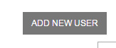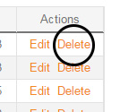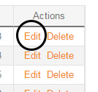Confirm deleting.

Figure (2-29) Figure (2-30) Figure (2-31)

**User Roles**

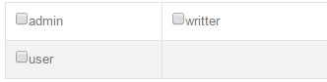There is 3 roles for users, each user is authenticated his own role which been chosen while creating his account (See Figure 2-32).

Figure (2-32)

* **User**: Doesn’t allowed to see any links in the settings menu, only viewing content and can only edit his own profile.
* **Writer**: Has the same rights as the user with few additional permissions:
  + Manage Circulars.
  + Manage Bulletins.
* **Admin**: Has the full access on the system, including all sections in the settings menu.

**Send Notifications**

In this section admins can send email notifications to all type of users whether by user names, emails or usernames. Also there is an option to send email notification to a whole group of users.

**Sending Notification**

* Go to “Send Notifications” page.
* Choose the users whom you want to send notification whether by typing their names (names, emails or usernames) in the top text-box, or simply choose a group of users to send them the notification together, also you can use both methods together (See Figure 2-33).
* Type in mail content as you wish.
* 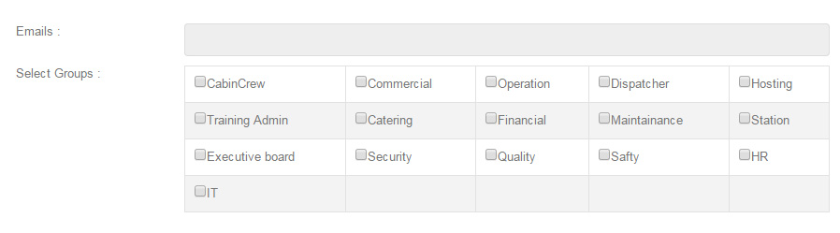Click on “Send” button.

Figure (2-33)

***3***

**USER GUIDE**

User pages are there for all roles (admin, writer or user), they contains the document viewing sections for the system, and they include the following pages (See Figure 3-1):

* Home (Dashboard).
* Circulars.
* Bulletins.
* Manuals / Aircraft Manuals
  + Manual Versions.
  + Manual Forms.
  + Manual Form Versions.

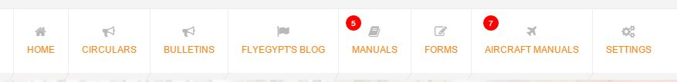

Figure (3-1)

**Home**

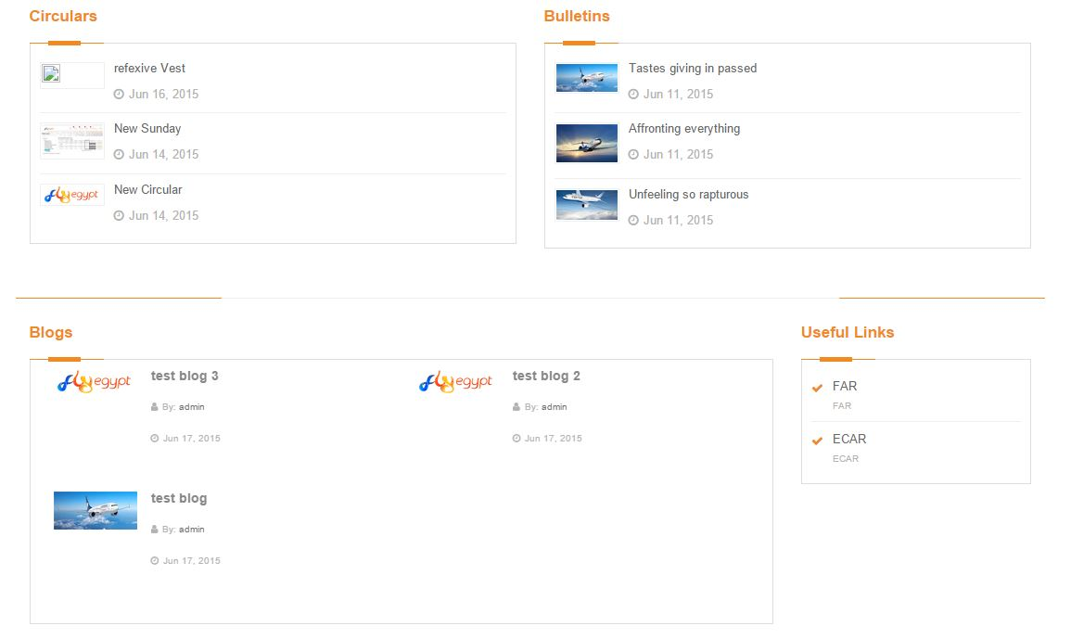Home page contains a summary of the latest data entered in Circulars, Bulletins, Blog and Useful Links (See Figure 3-2).

Figure (3-2)

**Circulars**

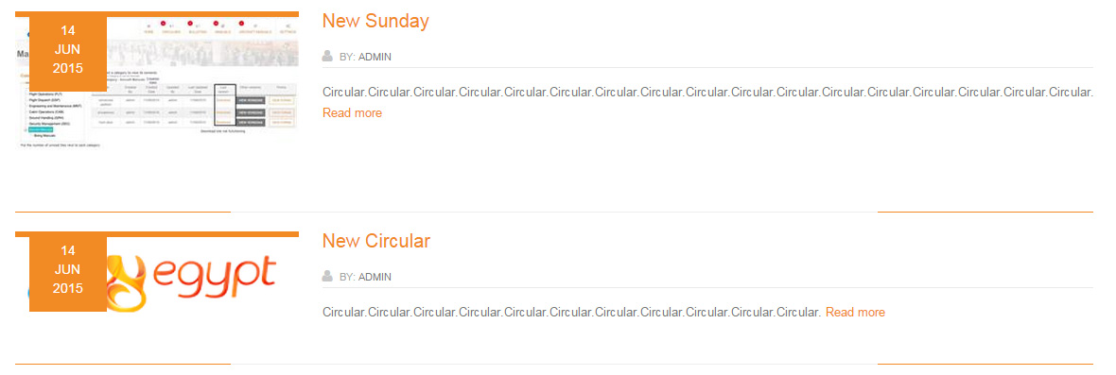Circulars page contains all the circulars in the form of vertical list (See Figure 3-3), clicking on any of them it’ll navigate you to the Circular Details and (See Figure 3-4).

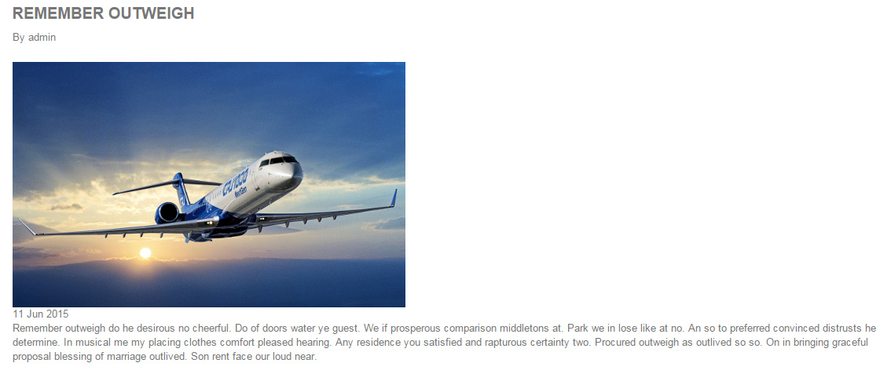Figure (3-3)

Figure (3-4)

**Bulletins**

Bulletins page contains all the circulars in the form of vertical list (See Figure 3-5), clicking on any of them it’ll navigate you to the Bulletins Details and (See Figure 3-6).

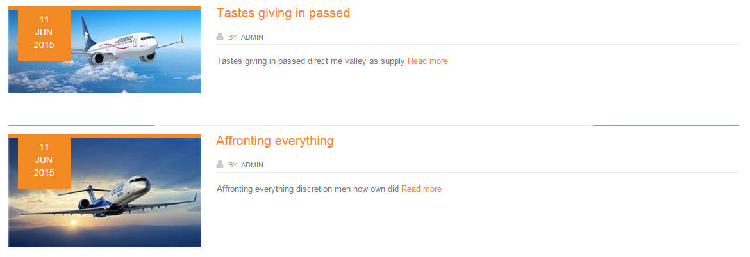 Figure (3-5)

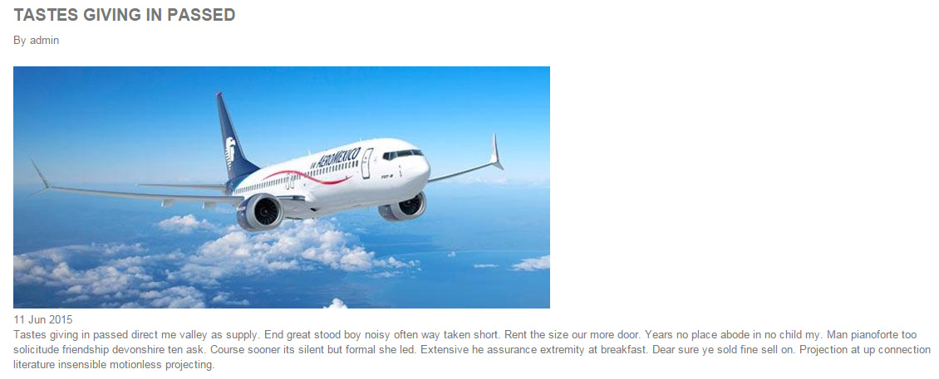

Figure (3-6)

**FlyEgypt Blog**

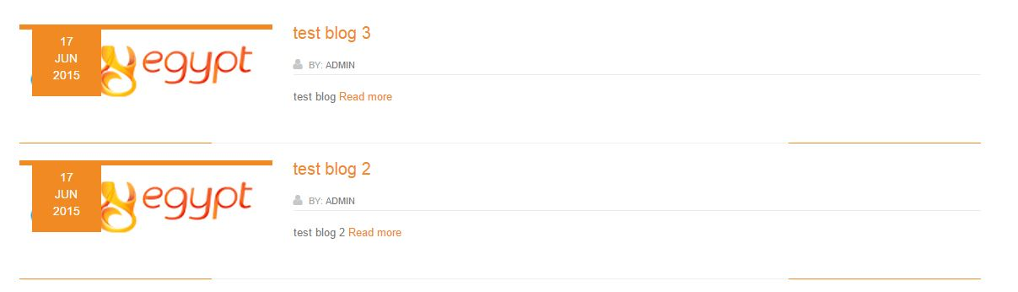FlyEgypt Blog page contains all the Blogs in the form of vertical list (See Figure 3-5), clicking on any of them it’ll navigate you to the Blog Details and (See Figure 3-6).

Figure (3-5)

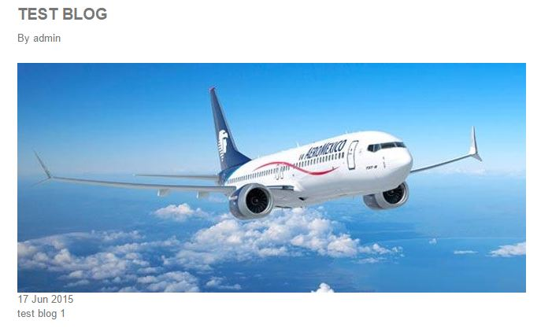

Figure (3-6)

**Manuals/Aircraft Manuals**

Manuals page contains the manuals data including manual versions, manual forms and forms versions.

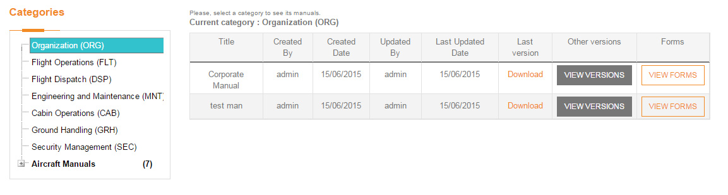The page also has the category tree on the right, from where you can choose which manual category you want to create, edit or delete. And on the other side there will be a table showing all data (See Figure 3-7).

Figure (3-7)

Each manual will be viewed under its category, latest manual version will be viewed by default in the table, to see older versions you have to click “View Versions” button and a pop-up dialogue will appear containing all manual versions (See Figure 3-8).

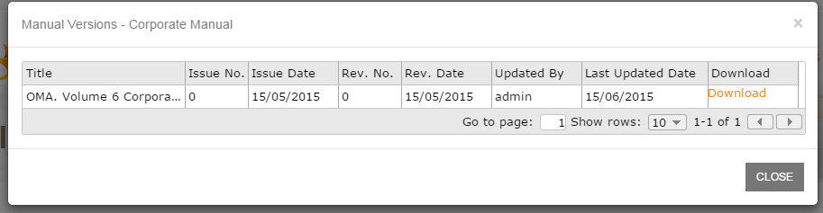

Figure (3-8)

To view manual forms, click on “View Forms” button for the desired manual, and it’ll navigate you to the specific forms page (See Figure 3-9).

Figure (3-9)

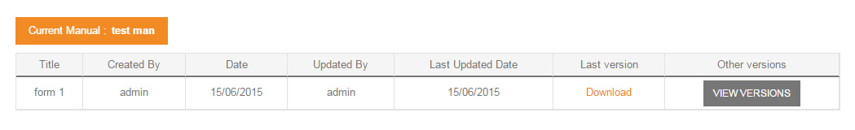

The same for forms page, the latest form version is viewed by default on the main table, to view older versions you have to click on “View Versions” button, and a pop-up dialogue will appear contains all the form versions (See Figure 3-10)

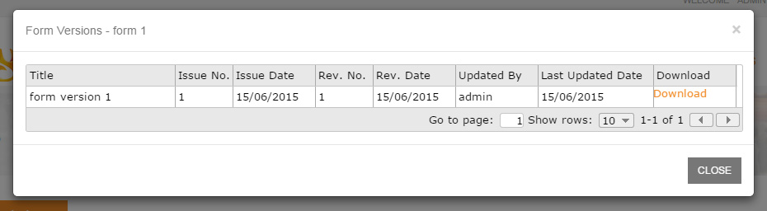

Figure (3-10)

**Profile and changing Password**

All type of user roles has the ability to view his own profile as well as to change his login password.

**View Profile**

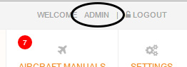To view your current profile, click on your name located at the top of navigation menu (see figure 3-11)

Figure (3-11)

**Change Password**

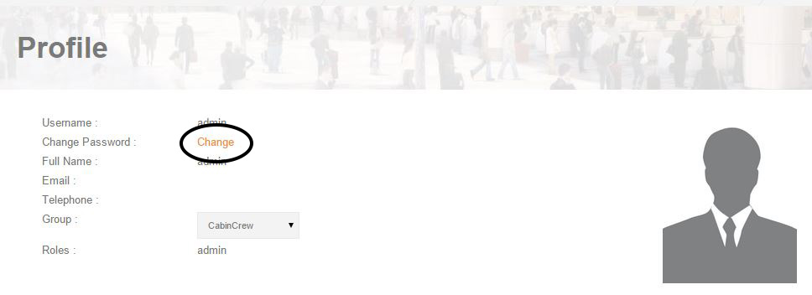To change your current password, click on your “change” located beside the “Change Password” label (see figure 3-12)

Figure (3-12)

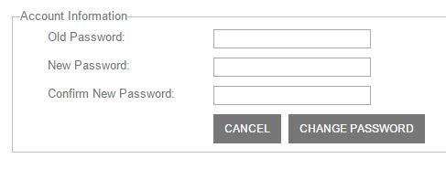Then fill the required fields: old password, new password and confirm password, then click on “Change Password” button (see figure 3-13).

Figure (3-13)

***4***

**NOTIFICATIONS MODULE**

**Overview**

Notifications works all over the system on all user roles (admin, writer and user)

There will be a notification for any new content created by system admins whether circulars, bulletins or manuals (see Figure 4-1).

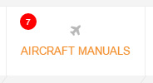 Figure (4-1)

I.e.: In the previous figure the notification counter indicates that there are 7 new/edited changes in Aircraft Manuals.

The same behavior will act for manual versions, forms and form versions (See Figure 4-2).

Figure (4-2)

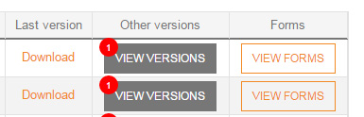

**Dismiss Notifications**

To dismiss notification you should open the page containing the modification.

I.e.: There is a notification counter indicates 2 new circulars, then you should open the circulars page to dismiss those notifications, same goes for other sections as well.

**I-Valley**

▪Heliopolis Cairo, Egypt ▪ (0020) 128 4040 78

▪ sales@i-valley.com ▪ www.i-valley.